**GROUP 5.9**

**Name - Rushikesh Nalla**

**ID - 201401106**

**Name - Omkar Damle**

**ID - 201401114**

**Activity modeling**

**CENTRALISED SCHOLARSHIP MANAGEMENT SYSTEM**

The Activity diagrams(with and without swimlanes have been shown below):

Because of size constraint the diagrams have been split into 3 images.

**Activity Diagrams(.dia) files are in the submission folder.**

After the activity model, we revised the class model. This is the final version of the class model.

Activity diagram(without swimlanes) :

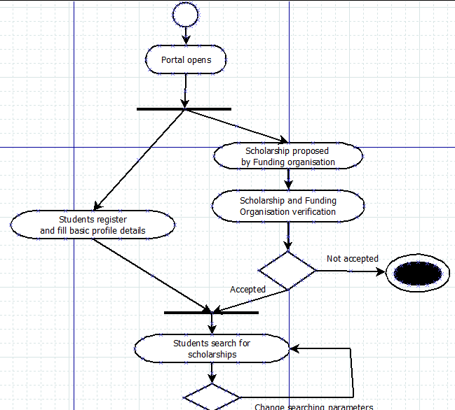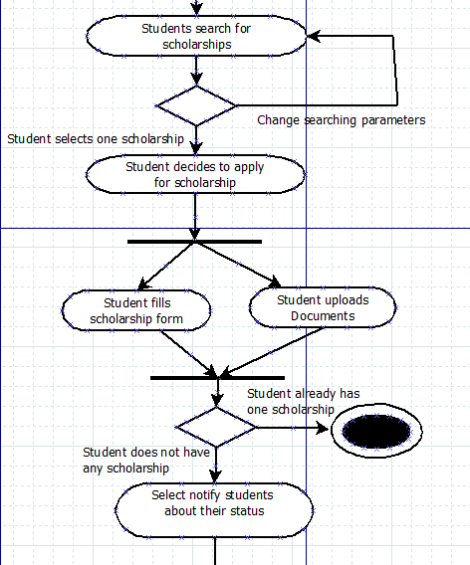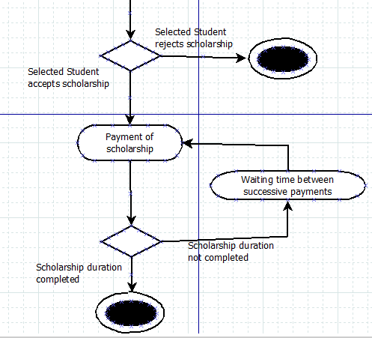

**Swimlane diagram : Refer to next page**

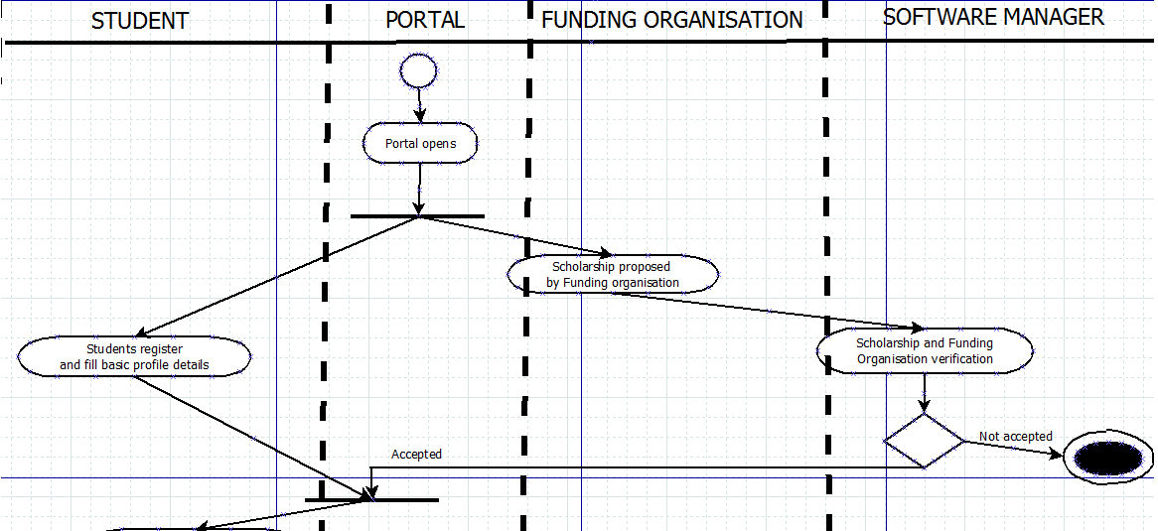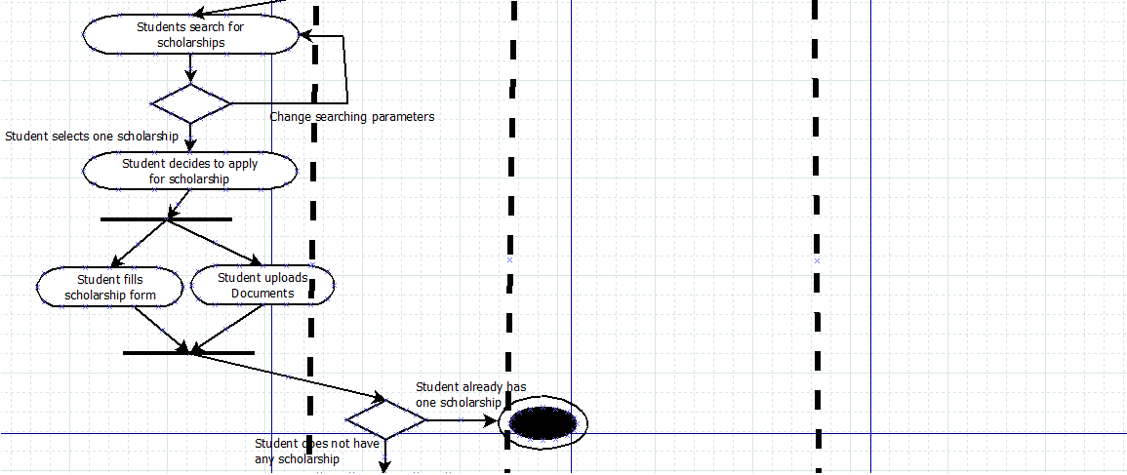

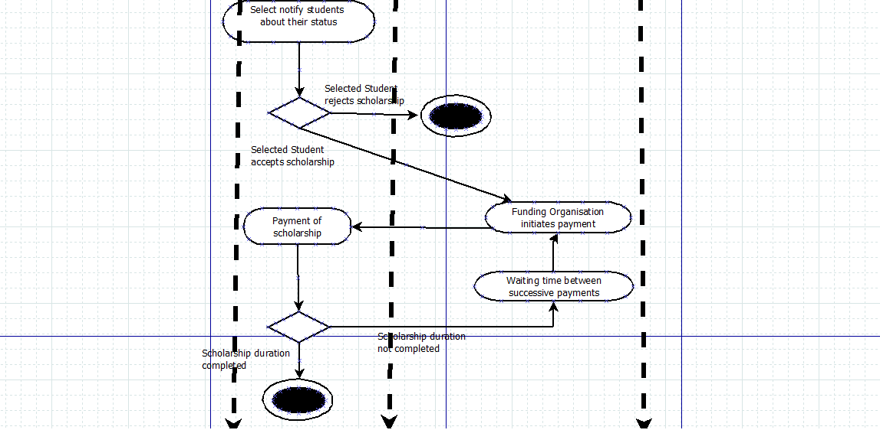

**REVISED CLASS MODEL :**

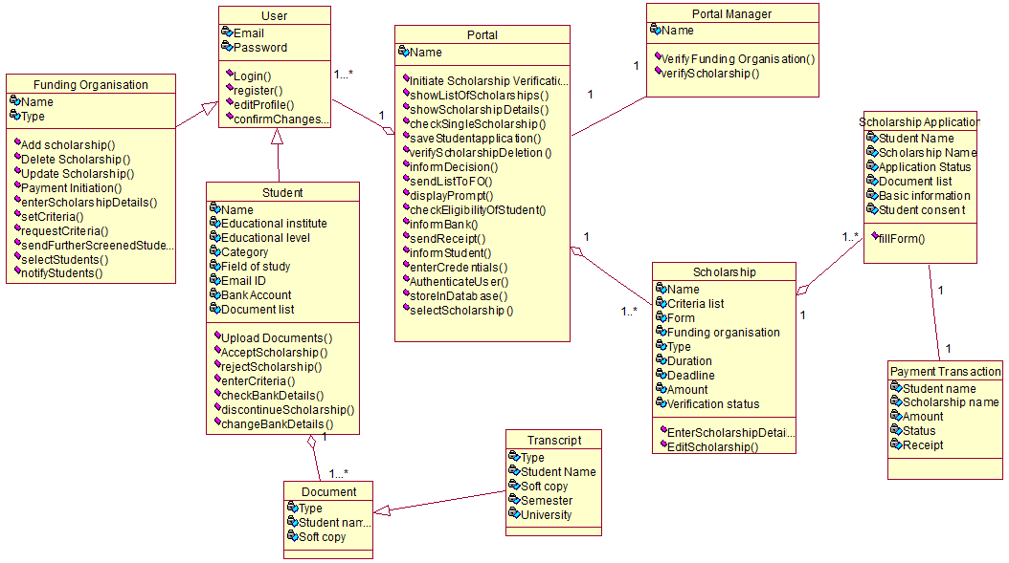

**Check finalClassModel.png from the submission folder.**